AdventureWorks Product Review MVP Documentation

Jadon Kosberg

May 8, 2026

Table of Contents

Section | Page Number
Executive Summary……………………..………………………….. | 3
Business Scenario…………………………………………………... | 3
Applications\Technical Documentation…………………………………………………… | 4
Problem Solving…………………………………………………….. | 10
Conclusions and Recommendations………………………………... | 11
Bibliography………………………………………………………... | 12

Executive Summary

AdventureWorks is a well-known bike company that has been around for 35 years. Lately, their old-school mail catalog orders have been dropping, so they are trying to move everything online. One big thing they are missing is a way for customers to actually leave reviews on the site.
For this project, I built a Minimum Viable Product (MVP) to show them how a review system would work. I set up two servers in the cloud using AWS, installed a SQL database with all their product info, and built a web page where people can actually leave a 1-5 star rating and a comment. This document explains the step by step process on how I put it together.

Business Scenario

The main problem is that AdventureWorks doesn't really know what their customers think of their products right now. They get some info from support calls, but there’s no place on the website for feedback.
The goal of this MVP was to create a system that lets customers browse the catalog and leave a review that includes their name, email, a 1-5 rating, and a comment. I had to make sure this new system worked with the data they already have. By doing this, the company can see which bikes people love and which ones might need improvements as they move away from the mail-order catalog.

Applications\Technical Documentation
Step 1: Setting up the AWS Environment
First, I had to create the environment for the project. I used AWS EC2 to launch two virtual machine servers running Ubuntu 22.04.
- One Server was for the web server and files. It was named Web Server A.
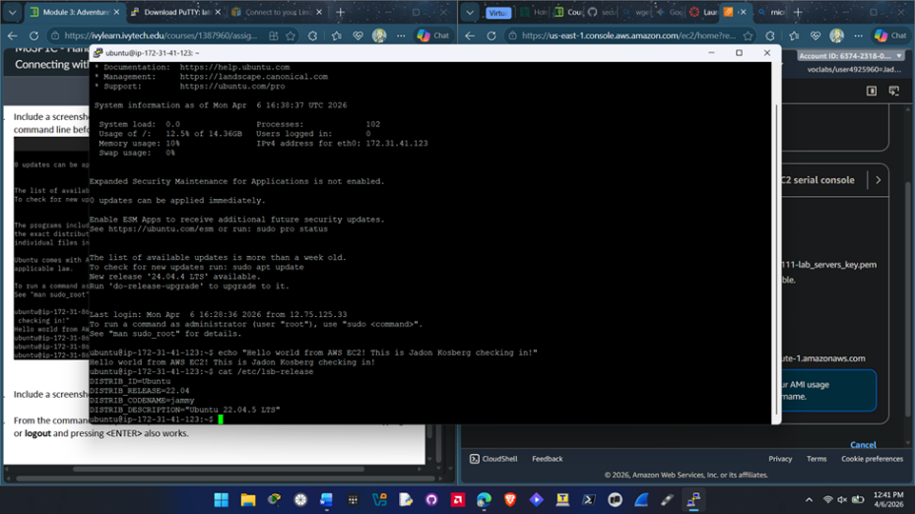
- The other server was for the database. It was named Database Server B.
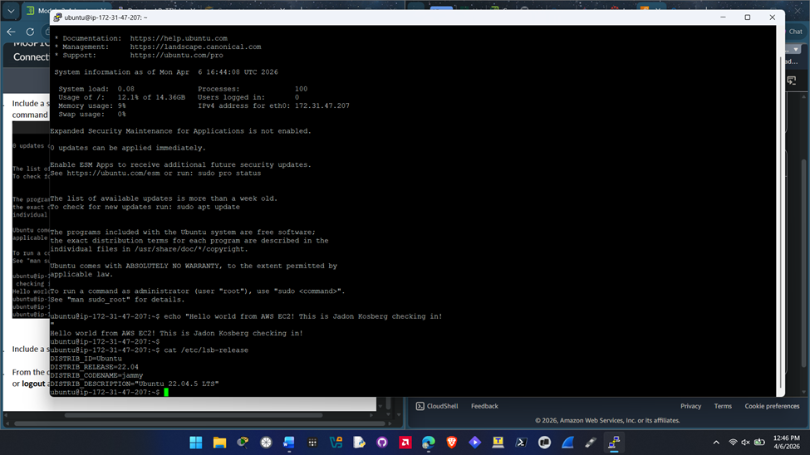
- In the AW2 EC2 security groups I set it up so I could use SSH to get in and also created inbound rules on so the two servers could talk to each other on Port 1433 and Port 80.

EC2 Instances listed:
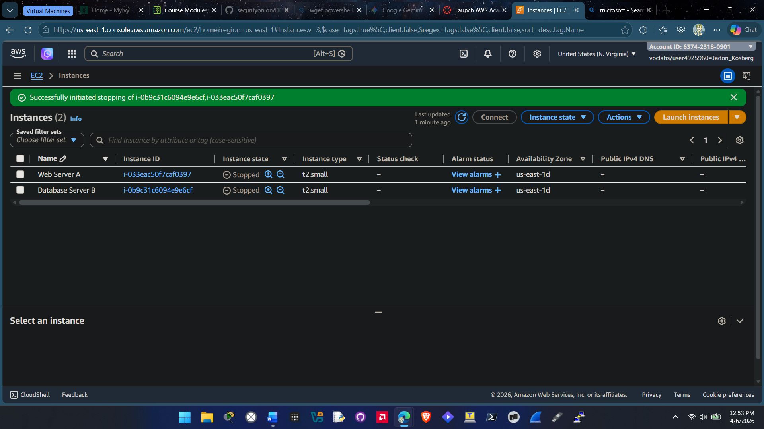
Inbound Rules Created in Security Groups:
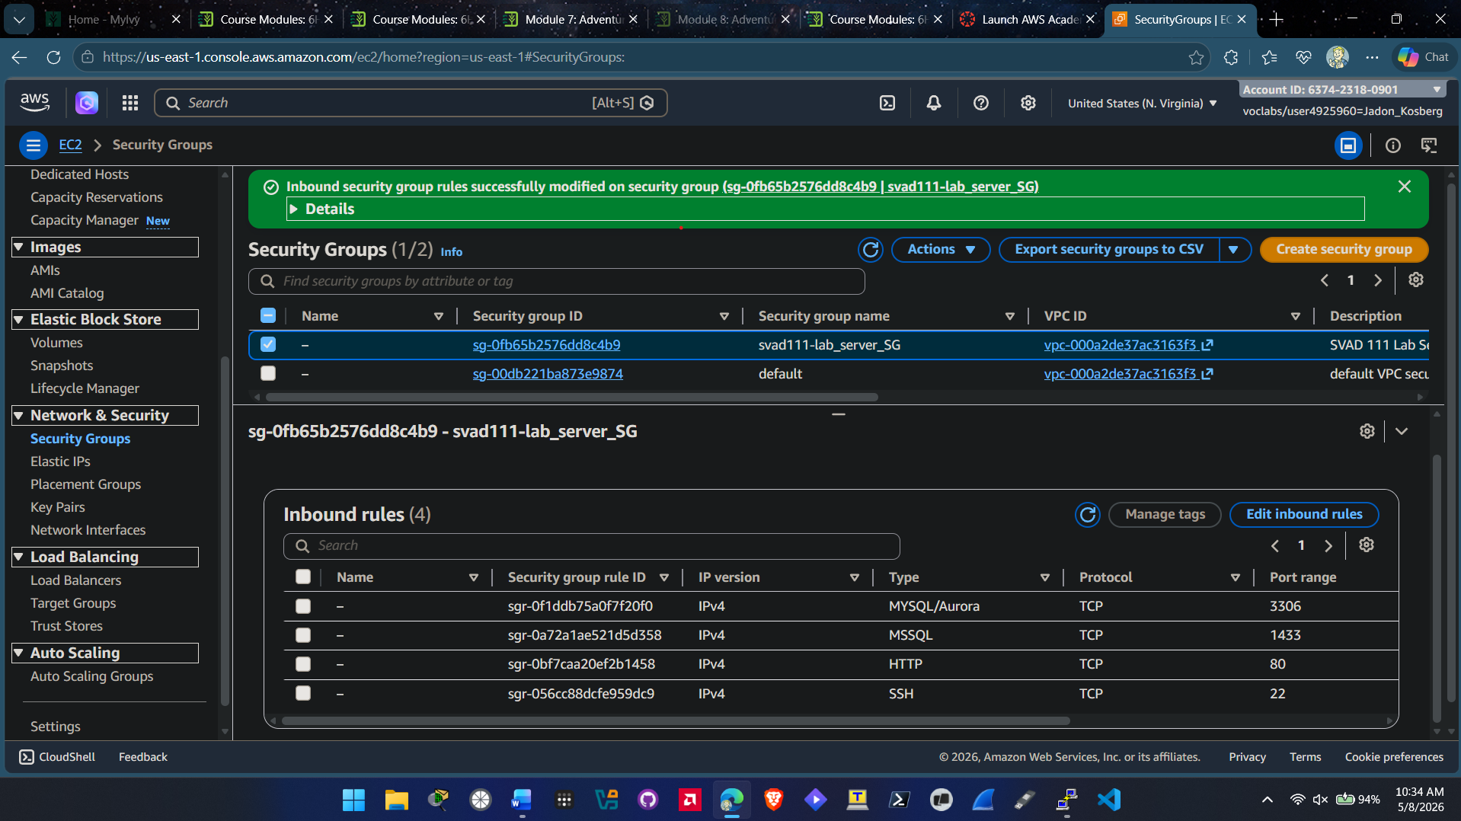
Step 2: Installing SQL Server and Importing Data
For the database server I installed Microsoft SQL Server for Linux. After getting it setup I then had to bring in the AdventureWorks data into the database.
- I downloaded AdventureWorks dataset and imported it into the database.
- Used WinSCP to transfer the AdventureWorks dataset into EC2 Intance.
- I used the sqlcmd tool to load the database and to verify that it works.
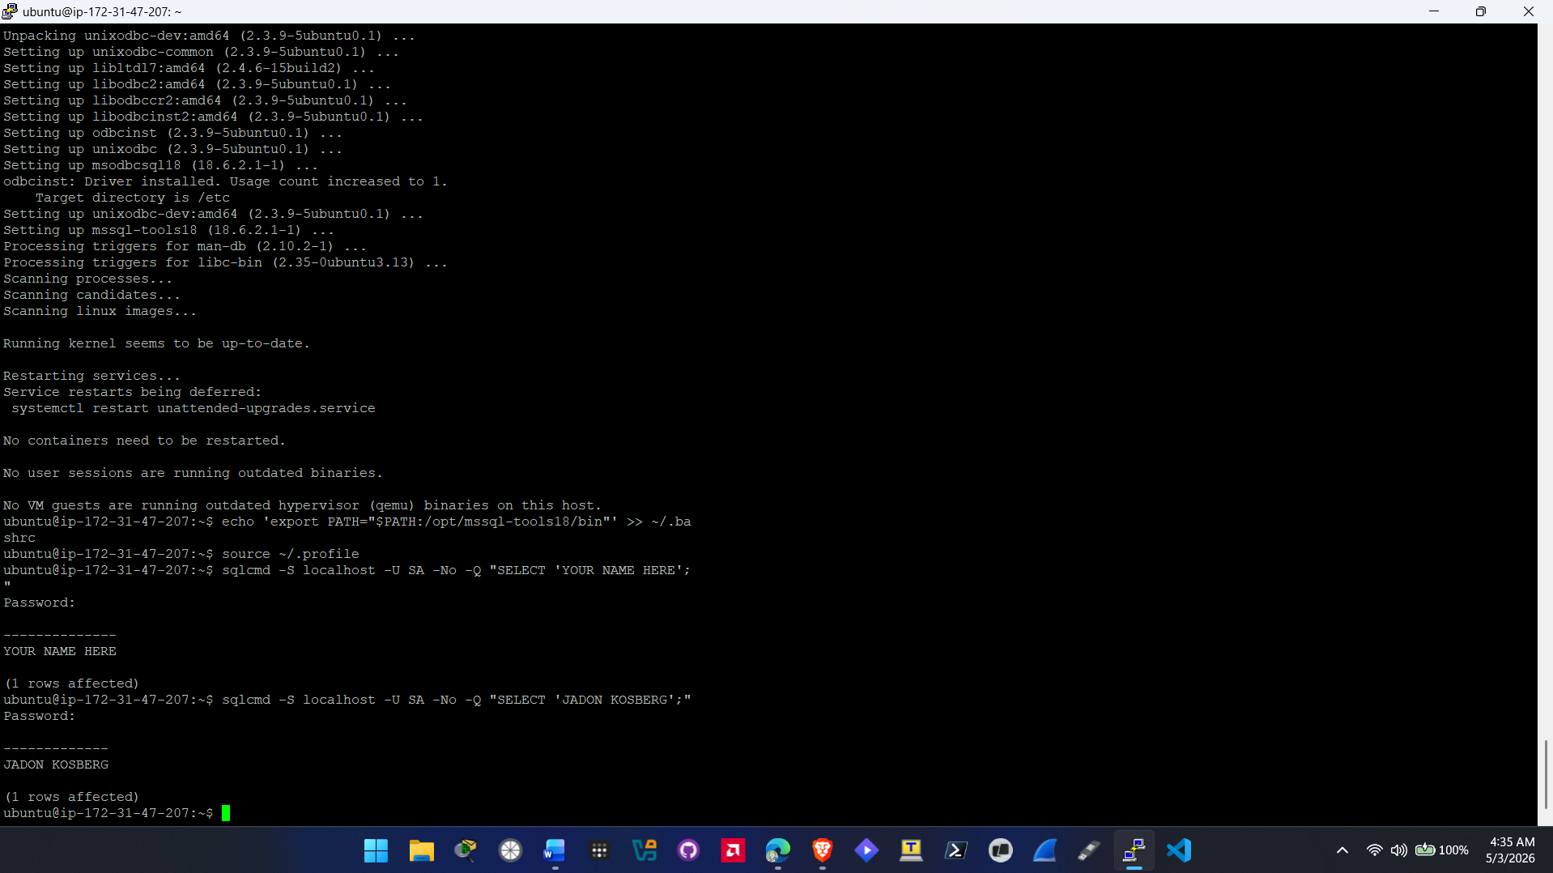
- I ran a few queries to validate the database was loaded successfully
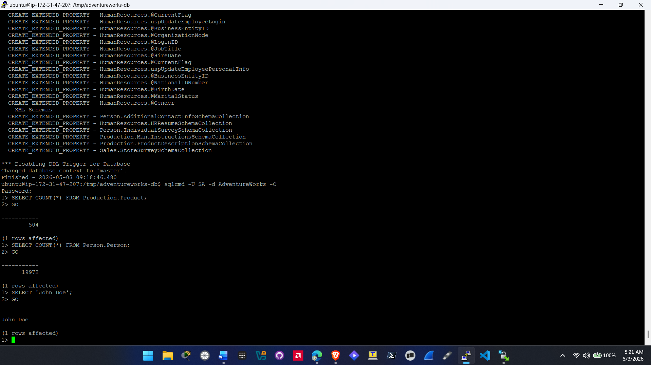
Step 3: Web Server and PHP Setup
On the second server, I installed the Apache web server and PHP.
- I had to install specific drivers so that PHP could talk to the SQL database on the database server.
- Verified the webserver worked with a test.php
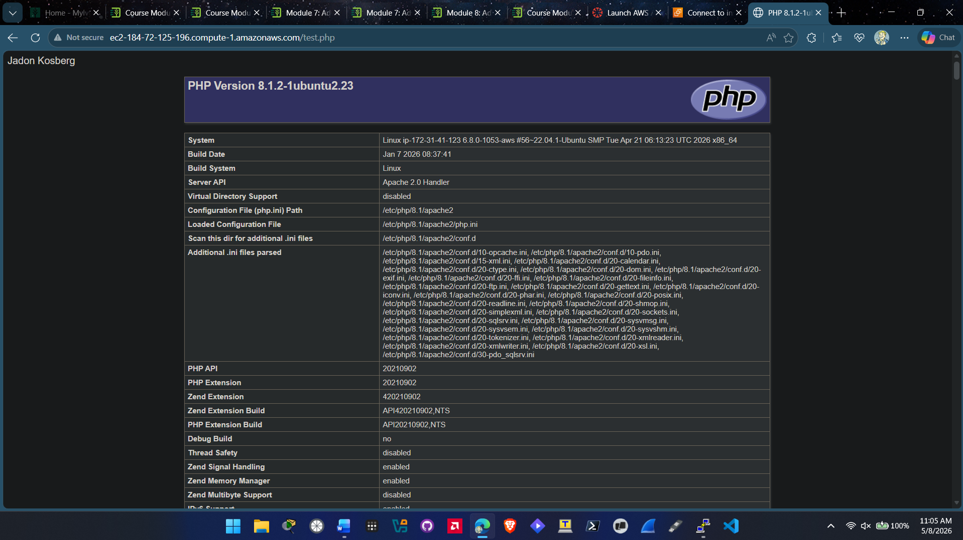
- I uploaded the AdventureWorks web files to the web server using WinSCP
- Extracted and moved the website files to /var/www/html
- I updated the configuration file, so the website knew the IP address of my database server for connection to the AdventureWorks dataset.
- Verfied the connection between the webserver and database server.

Working Web Application:
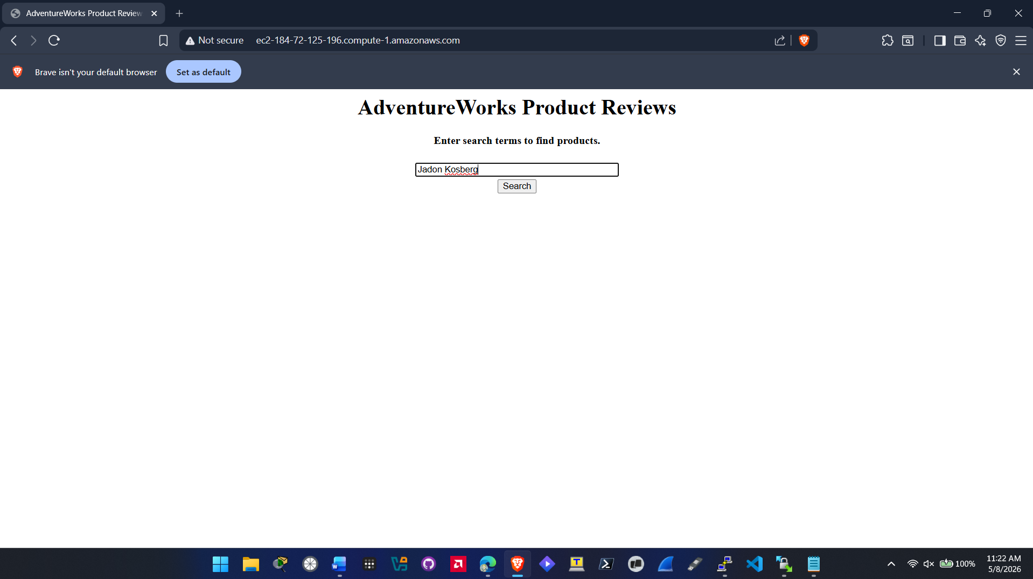
Step 4: Testing the MVP
Finally, With the web application working I tested it by searching for some products. I then specifically searched for a product and submitted a review to make sure it saved correctly to the database.
Searching for Products:
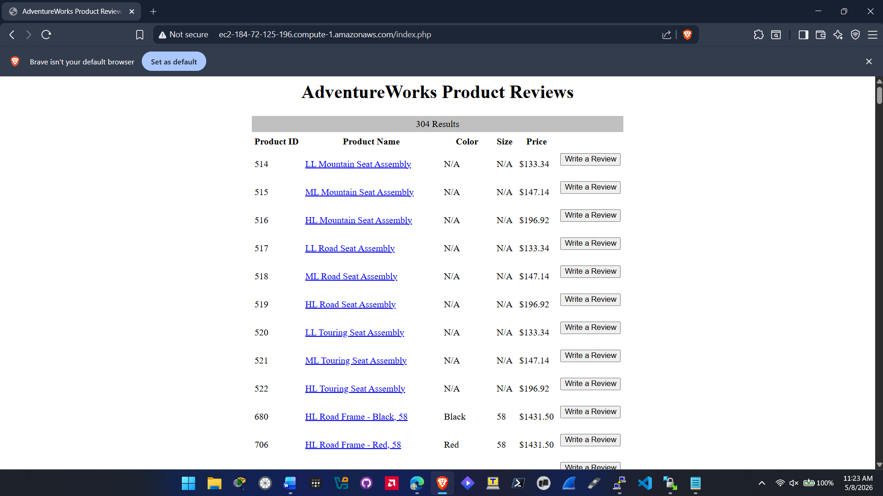
Searched for and found Mountain 300 Black 44 bike:
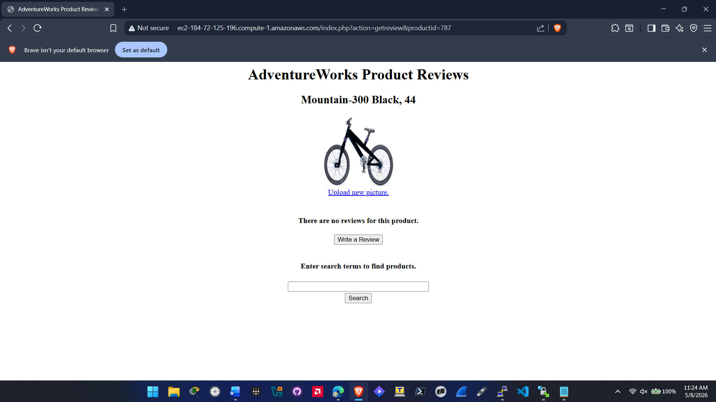
Review Functionality Test:
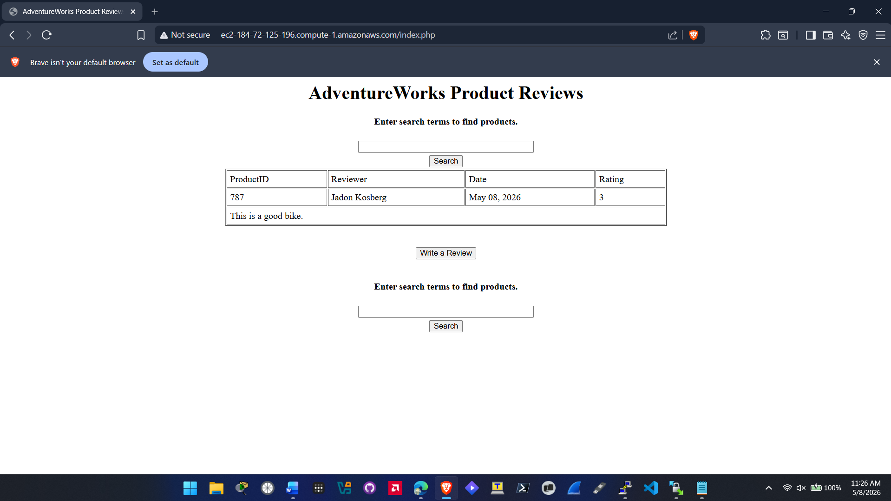

Search Test for Mountain-300
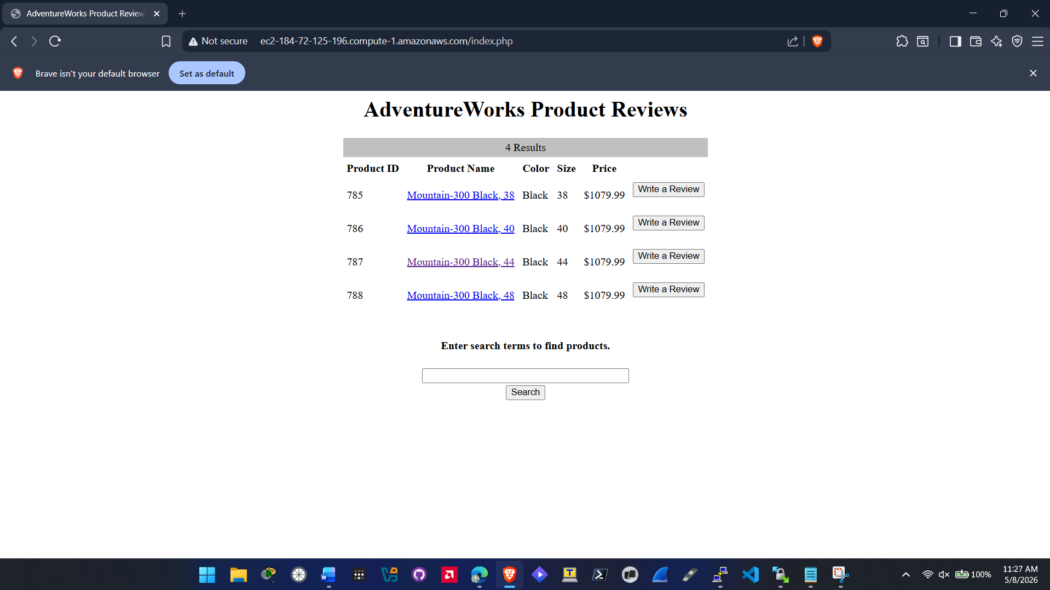

Problem Solving

Problem | Solution
Connection Timed Out: The web server could not talk to the database. | I had to go into my AWS EC2 Secuirty Group for my instances and add a rule to allow Port 1433 traffic from the web server.
SQL Login Failed: The web application couldn’t log into the database even with the right password. | I had to enable SQL Authentication during the setup.
Package Repository Errors: when running apt-get update, the server could not find Microsoft SQL packages. | I had to manually add the Microsoft repo keys and the repository link to the sources list for it to work.
Issue connecting to EC2 instances from Putty when first trying to ssh into them. | I realized that the network I was on was blocking outbound ssh connections so I had to switch to a hotspot.

Conclusions and Recommendations

The MVP is working and shows that we can link a web-based review system to our existing AdventureWorks data.

Recommendation:

- Added Security: We need to add an SSL certificate so we can utilize HTTPS since HTTP is not a secure protocol.

- Add User Accounts: Right now, anyone can leave a review. It might be better in the future to implement this so bot farming low ratings is prevented.

- Add Photos: It would be good if users could share a photo of them using the product to add in their review just as something extra.

Bibliography

Canonical. (2022). Ubuntu Server 22.04 LTS Documentation. Retrieved from https://ubuntu.com/server/docs

Ivy Tech Community College. (2026). SVAD 111: AdventureWorks Product Review MVP Project Overview.

Microsoft Corporation. (2023). Install SQL Server on Ubuntu. Microsoft Learn. Retrieved from https://learn.microsoft.com/en-us/sql/linux/sql-server-linux-setup-ubuntu

